The Menil Collection &

University of Houston India Studies

invite you to hear

Vinay Lal

in a lecture titled

Gandhi and the Politics of Visual Representation

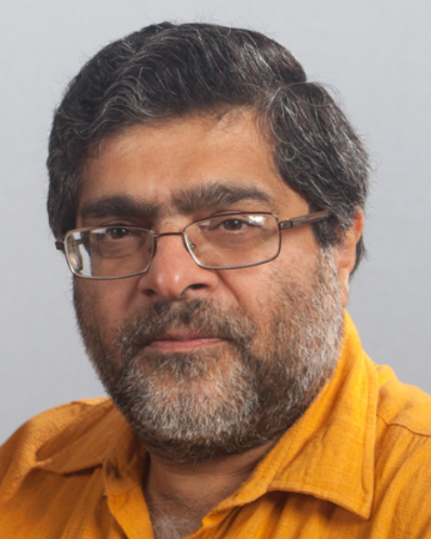
Vinay Lal, Photo courtesy: Daniel M. Neuman

The Menil Collection
Monday, October 27, 7:00 p.m.
1533 Sul Ross
The India Studies Program at the University of Houston is committed to the study of world cultures and the enhancement of
international understanding. India Studies offers courses on the history, politics, economics, cultures, languages, and religions of India.

Vinay Lal was born in India in 1961. He grew up in Delhi, Tokyo, Jakarta, and Washington, D.C., and earned his B.A. and M.A., both in 1982, from the Humanities Center at The Johns Hopkins University. He then studied cinema in Australia and India on a Thomas J. Watson Fellowship before commencing his graduate studies at the University of Chicago, where he was awarded a Ph.D. with Distinction from the Department of South Asian Languages and Civilizations in 1992. He was William Kenan Fellow in the Society of Fellows in the Humanities at Columbia University in 1992-93. Vinay Lal has been teaching History and Asian American Studies at the University of California, Los Angeles (UCLA) since 1993. Vinay writes widely on Indian history, the popular and public culture of India (especially cinema), the Indian diaspora, global politics, contemporary American politics, and the politics of knowledge systems.

His 14 books include the two-volume Oxford Anthology of the Modern Indian City ( 2013); Deewaar: The Footpath, the City, and the Angry Young Man (2011); The Future of Knowledge and Culture: A Dictionary for the Twenty-first Century, co-edited with Ashis Nandy (2005); Of Cricket, Guinness and Gandhi: Essays on Indian History and Culture (2005); The History of History: Politics and Scholarship in Modern India (2003).

He is presently working on several books, among them a monograph on Deewaar, an iconic work of mainstream Indian cinema; a scholarly and creative anthology on the Indian city; a study of visual representations of Mohandas Gandhi; a monograph, now nearing completion, on political trials in colonial India; a study of American exceptionalism and what he calls the dream-work of America, entitled The Radiance of Despotism; and two collections, one an edited work, of essays on Gandhi.

Vinay Lal speaks in Houston in conjunction with Experiments with Truth: Gandhi and Images of Nonviolence.



